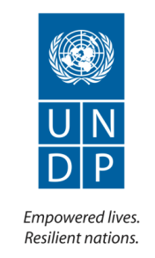

Preparation of National Human Development Report
Project

Annual Report
2013

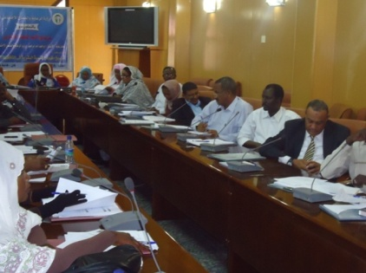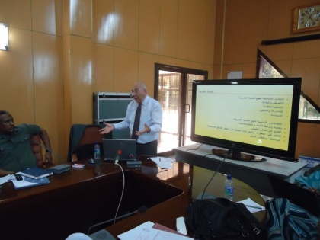

Implementing Agency: | United Nations Development Programme
Country/Region or Area: | Sudan
Project Title and ID: | Preparation of the National Human Development Report
Project Duration: | 1.06.2009 to 31.8.2014
Project Budget (AWP): | $1,620,000
Reporting Period: | 01.01.2013 to 31.12 2013
Total funds available (US $): | USD 200,000
Contact Person/s: | Elmoiz Ismail  Programme Specialist  Poverty Reduction and MDGs Unit,  Elmoiz.ismail@undp.org  +249912161653  Ext: 2204

Table of Contents

Acronyms

I. Executive Summary 4

II. Introduction 4

III. Progress Review: Key Activities and Results, <specify reporting period> 5

IV. Monitoring and Evaluation 6

V. Key Challenges and Lessons Learned 6

VI. Major risks and mitigation measures 7

VII. Partnerships and Sustainability 7

VIII. Financial Summary 7

Annexes

Acronyms

GoS  UNDP  NHDR  MoWSS | Government of Sudan  United Nations Development Programme  National Human Development Report  Ministry of Welfare and Social Security

- Executive Summary

Context:
This is the 2013 annual report for the “Preparation of the National Human Development” project. The report reviews project progress from January- December 2013. It presents a description of key achievements, challenges, and progress towards the accomplishment of project outputs.

The main objectives of the Human Development Reports are to engage people and institutions – government decision makers, civil society, the business community, academia and the public at large in informing policy decisions; to place people at the centre of the analysis, valuing expansion of choices and increased well-being

Key developments:
Progress against project outputs and outcomes:

The project contributes towards the Outcome 1: People in Sudan, with special attention to youth, women and populations in need, have improved opportunities for decent work and sustainable livelihoods and are better protected from external shocks, thereby reducing poverty.

The CPD output which is served by the project is “relevant public institutions are better able to measure and assess socio-economic vulnerabilities and review related policies and strategies in support of poverty reduction and achievement of MDGs”.

During 2013, relevant stakeholders( national and sub-national): decision makers and policy makers, civil society organizations, academia and media have participated in a series of five workshops designed for sensitization on the concept of human development, measurements and the preparation process of human development reports and support the advocacy strategy of the 2012 NHDR in order to equip stakeholders with the skills and techniques to analyze issues from a human development perspective. The workshops were successfully carried out with the extensive support and collaboration of the newly established human development unit at the Ministry of Welfare and Social security.

Project outputs: Advocacy campaign for the NHDR launched, and Partnership with the Society Studies Centre developed.

More specific results generated are listed as below:

- The first Sudan National Human Development Report (NHDR) of 2012 has been printed in both English and Arabic versions and disseminated to the public.
- A National Consultant has been recruited to implement (in collaboration with the Ministry of Welfare and Social Security) the advocacy strategy for the NHDR key messages. The strategy had been prepared by an International Consultant in 2012.
- The Ministry of Welfare and Social Security had previously provided office facilities which since early 2012 has been officially declared by the Minister as the “ Human Development Report Unit in the Ministry” to support the mandate of the Ministry in reporting to the Council of Ministers on Human Development reporting issues.,.
- A capacity development plan on the concept of human development and the preparation of HDRs was developed in February 2013 for stakeholders from government and non-government organizations, academia and media.. The plan included workshops which were successfully carried out with the extensive support and collaboration of the Ministry of Welfare and Social Security. The plan consisted of five one-day workshops and was attended by 180 participants: national and sub- national from seventeen States out of which 15 were media spokespersons. These workshops were organized to support the advocacy strategy of the 2012 NHDR and to equip stakeholders with the skills and techniques to analyze issues from a human development perspective. During the workshops, evaluation forms were distributed to participants and their recommendations firmly confirmed the importance of mainstreaming human development planning.
- The process of preparation of the NHDR 2013 is ongoing regarding the selection of the theme for the report and the research institution.

Update on financial expenditure: The total budget for the project for 2013 is USD 200,000, total project expenditure was USD 199,952.50.

Key challenges (risks and issues) and Lessons-Learned:
- The NHDR was drafted with information relevant to 2010-2011 and any information that may have been produced afterwards is not included in the analysis. At the same time, official dissemination of the NHDR is beneficial to the future potentials of the project implementation. The project is monitoring the results of similar publications for changing circumstances.
- The progress for achieving the project’s outputs and activities related to the preparation of NHDRs is challenged by a decision-making process that sometimes affects the project’s delivery. Frequent visits are undertaken to the Ministry of Welfare, the Human Development Unit, in order to stretch the tolerance capacity until decisions are made on the way forward.
- In terms of the preparations for the second NHDR, UNDP will encourage participation and consultation with various stakeholders on selection of theme and explore availability of data.
- Training for relevant core Authors and partners will be provided on Human Development concepts, measurements and applications, as well as on writing skills as appropriate.

Recommendations
More extensive capacity building and specialized efforts mainly workshops on Planning Development through a Human Development lens and human development measurements, for national and sub-national professionals and experts.

Technical advisor to do mapping of Ministries/stakeholders using Human Development data and to support the budget planners.
- Introduction

UNDP supports national policy dialogues in many countries, focusing on national development strategies and macroeconomic policies linked to sustainable human development. UNDP supports such national efforts through monitoring of human development. The National Human Development Report (NHDR) has proven to be one of the most successful UNDP methods for presenting analytical and evidence based tools for policy choice and dialogues at Global, regional and National levels.

NHDR has being introduced by UNDP in 2001. The NHDR is a user friendly method for analysis of human development at the national and sub-national levels – means for assessing human development situations, trends and gaps. NHDRs are not politically negotiated strategies with detailed implementation plans. NHDRs should be independently researched documents, providing independent and objective analysis of the situation and a full range of policy options to accelerate achievements in human development.

The Interim Poverty Reduction Strategy (2012) indicates that poverty remains persistent due to inefficient development plans and strategies, reduced public expenditures on basic services, and erosion of land and natural resources. UNDP uses this unique opportunity and supports the process of NHDR preparation and its advocacy to support Sudan in identifying recovery and development challenges in the national context and in support of progress toward the MDGs with a focus on promoting the inclusion of vulnerable communities, women and youth.

In 2005 the ministry of the council of Ministers issued a decree establishing the national mechanism (Advisory Board) for production of the national human development report and assigned the MoWSS as the overall government responsible Ministry to monitor and oversee the progress of NHDRs. The committee is composed of all stakeholders with a mandate relevant to Human Development. It is envisaged that these reports will contribute to national consensus building and policy formulation.

Project Objectives

The main objectives of the Human Development Reports are to engage people and institutions – government decision makers, civil society, the business community, academia and the public at large in informing policy decisions; to place people at the centre of the analysis, valuing expansion of choices and increased well-being.

Project Strategy
The preparation of the National Human Development Report, as an advocacy tool, is guided by the following six principles:

- National ownership;
- Participatory and inclusive preparation;
- Independence of analysis;
- Quality of analysis;
- Flexibility and creativity in presentation and
- Sustained follow-up;

The Primary Beneficiaries of the Reports:

The planners and policy makers who can use the findings of the report in developing policies, strategies, plans, programmes and budgets;
The report beneficiaries also include civil society organizations, in particular the press that can use the findings to advocate human development.
The 2010/11 NHDR report targeted advocacy for the rights of the poorest segments of the population, the underserved and other vulnerable groups including women, since the thrust of this inter-collaborative project is to focus on basic human development needs and poverty reduction.

The report will also orient donors’ interest to priority areas of human development.

MoWSS and UNDP are ensuring that the report is accompanied by strong advocacy activities covering outreach, communication, marketing and monitoring of the results and to help the report’s messages and recommendation to stay alive for a sustained period beyond the launch.

Another new feature will be a workshop for journalists to be organized prior to the dissemination of the report in order to enhance the quality of reporting for the NHDR issues. This will also help to train a number of qualified journalists who will address and promote in a more professional manner the issue of human development in Sudan.

Main Partners
Under the guidance of the National Advisory Committee on Human Development, UNDP Sudan and the Ministry of Welfare and Social Security (MoWSS) will recruit an independent team of intellectuals, through a competitive process, to prepare a solid analysis, report and recommendations to enhance the national progress on the selected human development themes. The Central Bureau of Statistics as well as other relevant government departments and stakeholders will support with activities related to collection of data, as well as assessment and review of information of the relevant theme.

- Progress Review: Key Activities and Results, January-December 2013

Section 1: Overall progress against outcomes

The project contributes towards the Outcome 1: People in Sudan, with special attention to youth, women and populations in need, have improved opportunities for decent work and sustainable livelihoods and are better protected from external shocks, thereby reducing poverty.

The CPD output which is served by the project is “relevant public institutions are better able to measure and assess socio-economic vulnerabilities and review related policies and strategies in support of poverty reduction and achievement of MDGs”. During 2013, relevant stakeholders( national and sub-national): decision makers and policy makers, civil society organizations, academia and media have participated in a series of five workshops designed for sensitization on the concept of human development, measurements and the preparation process of human development reports and support the advocacy strategy of the 2012 NHDR in order to equip stakeholders with the skills and techniques to analyze issues from a human development perspective. The workshops were successfully carried out with the extensive support and collaboration of the newly established human development unit at the Ministry of Welfare and Social security.

Section 2: Progress against each output

Project Output 1: National Human Development Reports produced.

Output indicators |  | Targets | Progress against targets
-number of advisory board meetings overseeing the preparation process and technical committees established.  -number of stakeholders reviewing the draft of the second report  -Peer reviewers established to review the report |  | Baseline: First 2012 NHDR produced.  Targets:  -report research team recruited and research process defined  - first draft of second NHDR completed and ready for review by stakeholders and peer reviewers | The Sudan National Human Development Report has been printed in English and Arabic and the dissemination ceremony has taken place.  proposal for the advisory board for the second NHDR is prepared and a meeting will take place during the last quarter of 2013 to discuss the selected theme and institution.  Activities for initiating the preparation process for the second NHDR will soon take place.
Project Output 2: NHDR messages promoted and policy outcome monitored

Output indicators |  | Targets | Progress against targets
-No of policy discussions that occur as a result of NHDR advocacy activities.  -Press materials on NHDR and key messages |  | Baseline:  2012 NHDR is produced with key messages for debates on Human Development  Targets:  -At least 30 media spokesmen trained on NHDR advocacy  -At least 3 policy discussions for NHDR advocacy  -At least one TV/Radio show hosted on NHDR messages  - Launching at least one NHDR network discussion through HDR UNDP website.  -at least 50 brochures/leaflets of NHDR key messages disseminated to key stakeholders and media | Around fifteen media spokespersons were trained on the concept and measurements of human development and the preparation of reports. The training took place in preparation for the 2012 NHDR outreach strategy for policy dialogue on key messages. A second round of training for media has taken place prior to the dissemination ceremony of the report in ways of communicating its messages to the public.  UNDP supported the Ministry’s initiative of releasing a newsletter featuring the development agenda of the Ministry. The first version of the newsletter released in August 2013 discussed the capacity development for human development program of the stakeholders from government and non government agencies, Academia and Media supported by the Ministry and UNDP in preparation for the advocacy campaign for the dissemination of the first Sudan 2012 NHDR.  The policy discussions, TV/Radio shows, NHDR network discussion and the promotional materials for the key messages are prepared and will take place soon after the dissemination of the 2012 NHDR to the stakeholders and public during the month of September 2013.
 | Project Output 3: Promotion of HD issues and concepts
Output indicators |  | Targets | Progress against targets
-no. of sessions on HD measurements  -course outline on HD produced  -no of researches on HD issues |  | Baseline:  First Sudan 2012 NHDR disseminated to stakeholders, Universities introducing Human Development issues  Targets:  -no. of persons trained on HD measurements  - HD course established in University  - At least one institution involved in research on HD issues  -establish resource library on HD | During February 2013, a series of five workshops were conducted to train around 180 relevant stakeholders from government and non-government organizations on the concept, measurements of human development and the preparation of HD reports.  The processes of MDG and NHDR report processes in data use were discussed as part of the curriculum of the capacity development for human development program as well and departments of budget planning in the Ministry have strongly participated.  A concept note for the establishment of an HD course series for the promotion of HD issues and studies was prepared and shared with a selected prestigious institute for development studies and research (DSRI) linked to the University of Khartoum. The courses include diploma and tailor made short courses designed for decision and policy-makers as well as postgraduate students.  The institute is planned to be involved in HD research through offering of research grants on key HD issues in Sudan for postgraduate students and as well in the establishment of a resource library and external international networks with Universities.

Key Activities and Key Results:
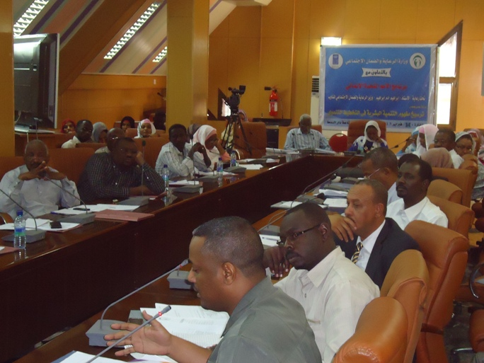

Inclu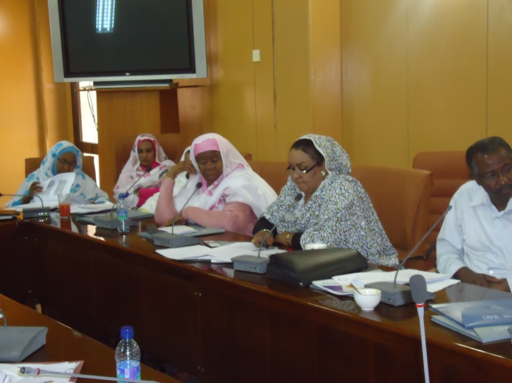de a pict ure relevant to the output as much as possibl e. This could also be graphs / diagrams that can further elaborate on achieved result

 | Output 1: Second National Human Development Report Produced
Activities |  | Key Results
- Activity Result  Launch of first Sudan NHDR 2012  Action 1: Launch ceremony for the dissemination of the report to stakeholders.  The Arabic and English reports are both printed and dissiminated to the public which will facilitate the preparation for the development of the second NHDR.  - Activity Result  Preparations for second NHDR Sudan  Action 1: Brainstorming with national policymakers and key stakeholders, for lessons-learned workshop and reviewing national strategies and policies to discuss the concept note of NHDR 2013  Action 2: Facilitate regular HDR advisory meeting for coordination mechanisms/purposes ie establishing content technical committee and supervising the preparation process  Both the concept note for selection of the theme for the second NHDR the Advisory Board will take place within 2013 |  | Dissemination of the Arabic/English 2012 NHDR has taken place with the collaboration of the Ministry of Welfare and Social Security the main partner supporting implementation of the project. The first draft of the 2012 NHDR was submitted in May 2011 and was sent to RBA/RBAS and HQ/HDRO for technical and political review and was recommended for publication. The report –for all of Sudan- was launched in July 3rd 2011 where over 250 stakeholders from government and non-government, Academia and media attended. The printed version has information concerning north Sudan only.  The first Sudan first 2012 NHDR is titled “Geography of peace: Putting human development at the centre of peace in Sudan”. The Report for first time calculates sub-national disaggregated HDI, with Khartoum State the highest at 0.7 followed by Gezira States at 0.69. The Report as well makes an attempt at a Multiple dimension Poverty Index and a human security index. The report was extensively reviewed by over 750 stakeholders from government, non-government, civil society, Academia and Media.  In terms of the second NHDR, UNDP is preparing for developing the concept note for the theme selection. Several issues are proposed and in collaboration with the Ministry of Welfare a brainstorming meeting with stakeholders from government, non-government and Academia and Media will soon take place.  The Council of Ministers in 2005 had issued decree No. 55, delegating the Ministry of Welfare and Social Security the preparation for the Human Development status reports for Sudan in addition to establishing a National Mechanism for supervising the process and reviewing the reports drafts. In this regard, the Ministry had issued in 2009 a decree No. 3 nominating the National Mechanism (considered Advisory committee for the report) for the first 2012 NHDR, from stakeholders of government and non-government, Academia and media. The committee was chaired and hosted by H.E Minister of Social Welfare and Social Security.  UNDP will explore the prospects of changing or adding to membership of the National Mechanism (Advisory Board) according to the requirements of the selected theme.
Output 2: 2012 NHDR messages promoted and policy outcome monitored
Activities |  | Key Results
Activity Result 2.1:  Outreach strategy for promoting first NHDR 2012 messages  Action 1: Pre-launch and launch ceremony campaign activities for NHDR 2012 dissemination.  Action 2: Meetings, stakeholders’ events, short policy meetings with target audiences (primary and secondary) and key messages to influence particular policies and discuss the potential threats to and opportunities for achieving these goals. Instruments include: meetings, stakeholders events and short policy summaries as well as establishing synergy with MDG report team.  The pre- launch activities for the campaign of the 2012 NHDR included the execution of a series of workshops for capacity development for HD on the concepts, measurements and preparation of reports.  Around fifteen Media spokespersons have participated. A plan is set in collaboration with the Ministry of Welfare to support the implementation of the advocacy meetings/policy discussions for key messages in the report. |  | The project recruited in 2012 International consultant for the development of an advocacy and outreach strategy for the key messages in the report.  A National Consultant was also recruited in 2013 for the implementation of the advocacy strategy. The consultant began the campaign when a series of five one-day workshops were taking place in February 2013.  Several articles were placed on local newspaper featuring the workshop events, and participants were around 180 from national and sub-national stakeholders: decision makers and policymakers, Academia and around fifteen media spokespersons.  The promotion of the key messages in the report will take place in collaboration with the Ministry of Welfare and Social Security and a plan is prepared for carrying out around four policy discussions.
Output 3: Promotion of HD issues and concepts
Activities |  | Key Results
- Activity Result  Promoting HD issues and studies and measurements  Action 1: HD issues and measurements for capacity development to equip stakeholders on methods of analysis  Action 2: Establish training course and lecture series to promote HD concerns and issues in institution/Universities  Action 3: Establish post-graduate research grants on theme and issues of HD  The training course and post-graduate research grants is planned to take place in a prominent institute selected with the collaboration of the Ministry of Welfare. A concept note was prepared and shared with the institute.  - Activity result  Inclusive partnerships mechanisms established  Action 1: This activity aims to develop a system of complementary links between MDG and NHDR report processes in use of data |  | A capacity development plan was set up during February 2013 for stakeholders from government and non-government organizations, academia, and media, on the concepts of HD and the preparation of HDRs. The workshops were successfully carried out with the extensive support and collaboration of the Ministry of Welfare and Social Security, and the coordination of the established Human Development Unit at the Ministry. The plan consisted of five one-day workshops and was attended by 180 participants: national and sub- national from the seventeen States: one for high-level participants from the Council of Ministers and Undersecretaries of Ministries, and a second for mid-level participants, the legislative members of the National Assembly and State Commissioners. The last three workshops were attended by Director-Generals of Ministry of Health and Education and Strategic planning and Bureau of Statistics as well as civil society organizations, private sector and Academia (Annex 2 attached with details). These workshops were organized to support the advocacy strategy of the 2012 NHDR and as well in order to equip stakeholders with the skills and techniques to analyze issues from a human development perspective.  Complementary links between the MDGR and the NHDRs were also discussed as part of the workshops program. Persons directly related to budgets planning were among the participants of the workshops.  During the workshops, evaluation forms were distributed to participants for evaluating, the structure and contents of the workshops, the facilitator and facilitation, and the value added to participants. The general response of the participants to these questions was mostly excellent.  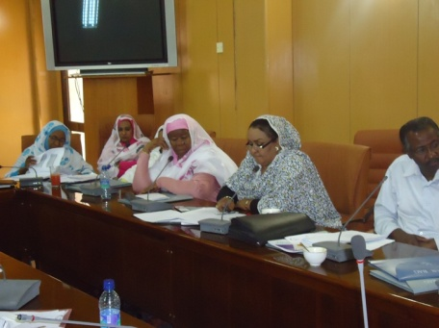  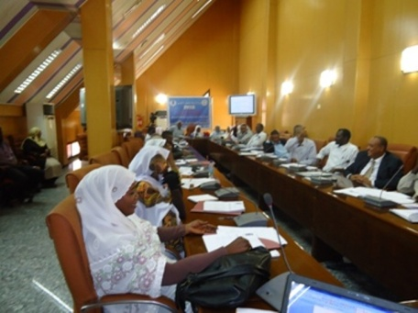  A concept note was prepared and shared with a selected institute in the University of Khartoum – Development Studies and Research Centre. The concept note includes the development of a plan for the implementation of a course series on Human Development on issues related.

- Monitoring and Evaluation

The implementation modality for this project is UNDP direct implementation through partnership and cooperation with the Ministry of Welfare and Social Security. The choice of the UNDP direct implementation was due to the fact that UNDP Sudan has adequate capacity to provide the technical assistance needed for the processes of development and dissemination of Human Development Reports according to HQ/HDRO methodology, which will benefit the project and achieve the expected outputs. Throughout implementation, both UNDP and Government ensure various measures for strengthening government and civil society ownership of the results of the project.

The project is reported on, monitored and evaluated in accordance with UNDP standard procedures. Reports are produced as per UNDP’s Results-based management project cycle directives that are from 2013 on bi annual and annual bases.
The reports are based on quality assessment records progress towards the completion of key results, based on quality criteria and methods An Issue and Risk Logs are activated in Atlas and updated to facilitate tracking and resolution of potential problems or requests for change.

During the Project cycle regular visits are undertaken by the Project Manager to the established human development unit at the Ministry of Welfare and Social Security. The Unit from early 2012, is linked to the Undersecretary’s and the Minister’s weekly meetings respectively, and involved in issues with to the mandate of the Ministry. Weekly reports by the Minister to the Council of Ministers are also shared with the Unit and documented.

- Key Challenges, Lessons Learned and Recommendations

- A major challenge in the implementation process is the choice of core Authors for carrying out the research which includes choice of research entity as well as contributors list of the background papers central in the HDRs drafting in order to maintain the independence of the report. Employing a consultative and participatory approach is selection of theme and research entity as well as in review of the report will ensure success of project objectives as well as identification of human development priorities in the country.

- The process of drafting the NHDRs requires the recruitment of a specialized HDR expert usually through UNDP. The involvement of the consultant from the beginning of the process is crucial in streamlining the HDR and in speeding the process of production. The first 2012 NHDR was drafted under the guidance of an HDR Specialist who also supported the team with the calculations of relevant indices.

- Extensive capacity development and sensitization efforts for both the relevant Author team and the national and sub-national governments and UNDP Staff in HD concepts and measurements and HDR’s preparation as well as training on writing skills as appropriate supports the process of research oriented policy analysis.

- A communication strategy for key messages of the NHDR is significant in expanding knowledge and understanding about HDRs and mainstreaming human development concerns into policymaking.

- Strengthening NGOs and CSO’s Networks working in the field of Peace as well as Development would enhance the awareness of human development and importance of human development reports in producing policy dialogue.

- UNDP to deploy a Technical advisor to do mapping of Ministries/stakeholders using HD data and to support the budget planners on operationalizing HD conceptual framework in the planning and policy making process.

- Update on risks and mitigation measures

The Report was drafted with information relevant to 2010-2011 and any information that may have been produced afterwards is not included in the analysis. The project is monitoring the results of similar publications for changing circumstances to ensure consistency of the data. The progress for achieving the project’s outputs and activities related to the preparation of NHDRs is challenged by a decision-making process that sometimes affects the project’s delivery. Frequent visits are undertaken to the Ministry of Welfare, the HD Unit, in order to stretch the tolerance capacity until decisions are made on both the dissemination of the first 2012 NHDR and preparations of the second NHDR where a participatory and inclusive process will be ensured to guarantee independency.
- Partnerships and Sustainability

The partner for the project the preparation of the National Human Development Report is the Ministry of Welfare and Social Security.

- The partnership with the Ministry of Welfare and Social Security facilitated the process of implementing the project activities in their
  - Kind contribution of office premises for NHDR
  - Support of team of authors in conducting the field process in states
  - Logistic arrangements for the review meetings of reports drafts by advisory board and ministry as well as during launch ceremony of report.
  - Advocacy for the production of the report with decision makers in other government ministries as well as civil society organizations.
  - Capacity development for stakeholders: Decision and Policy makers from government and non-government organizations, Academia and media to analyze issues from human development perspective
  - Follow-up on human development index for Council of Ministers through establishment of the Unit to as part of the Ministry’s Council and mandate to ensure sustainability of project.

- The preparation process of the report was completed using a participatory approach with government, CSOs, development practitioners, and academicians and students in all of its stages: selection of report theme and author team, field research with population in eight states, and review of Reports drafts. This process strengthens the networks of those working in the field of Peace as well as Development and enhance the awareness of human development and importance of human development reports in producing policy dialogue for sustainability.

- The drafting of the theme peace and human development and the detailing of the human costs of insecurity and struggle at this important time in the history of the country had addressed the livelihood needs of the population and therefore provided a strategic entry point in setting up poverty reduction initiatives.

- Financial Summary

Table 1: Overview of available resources for the period January – December 2013

Donor | Opening Balance 2013 | Allocations 2013 | Total
UNDP TRAC |  | 197,305 | 197,305
UNDP 11888 |  | 2,695 | 2,695
Total | 0 | 200,000 | 200,000

Table 2: Overview of Budget and Expenses per output

Output | Budget (USD) |  |  | Expenses (USD) |  |  | Balance
 | UNDP TRAC | UNDP 1188 | Total | UNDP TRAC | UNDP 1188 | Total
Management | 9,300.00 |  | 39,300 | 50,124.94 |  | 50,124.94 | (10,824.94)
National HDR Printed and disse | 27,305.00 | 2,695.00 | 30,000 | 32,676.35 | 2,882.90 | 35,559.25 | (5,559.25)
Partnership with the SSC | 86,350.00 |  | 86,350 | 114,268.31 |  | 114,268.31 | (27,918.31)
Advocacy campaign for the NHDR | 44,350.00 |  | 44,350 |  |  |  | 44,350.00
TOTAL | 197,305.00 | 2,695.00 | 200,000 | 197,069.60 | 2,882.90 | 199,952.50 | 47.50

Table 3: Overview of expenses Per Categories

Category | Amount (USD)
Contractual Service -Individuals | 38,395.53
Local Consultants | 48,235.23
International Consultants | 15,000.00
Audio Visual&Print Prod Costs | 57,169.39
Contractual Services-Companies | 17,600.75
Communic & Audio Visual Equip | 825.54
Learning and Training Workshop | 5,856.70
Travel | 616.25
Rental & Maintenance-Premises | 8,994.34
Supplies | 3,101.19
Professional Services | 724.64
Contributions to Common Services | 2,570.41
Miscellaneous Expenses | 716.88
Facilities and Administration | 188.60
Foreign Exchange Currency Loss | (42.95)
Total | 199,952.50

Data contained in this report is an extract from UNDP financial records. All financial information provided above is provisional. Certified financial statements will be provided if required.

Annex 1: Progress Review: detailed matrix of activities and results

Output 1 | Indicators |  | Baseline | Annual target | Progress / target
Second National Human Development Report produced.  Budget:$ 110,000  Expenditure to date: $ | - number of advisory board meetings overseeing the preparation process and technical committees established |  | First 2012 NHDR produced | Report research team recruited and research process defined | Activities for the second NHDR will take place after coordination with the Ministry of Welfare.
 | - number of stakeholders reviewing the draft of the second report |  |  | First draft of second NHDR completed and ready for review by stakeholders and peer reviewers
 | - peer reviewers established to review the report
Planned activities |  | Results
Activity 1: Launch of first Sudan 2012 NHDR
1.1. Launch ceremony for the dissemination of the report to stakeholders. |  | The launch ceremony has taken place
Activity 2: Preparations for second Sudan NHDR
2.1: Brainstorming with national policymakers and key stakeholders for workshop reviewing national strategies and policies to discuss the concept note of second NHDR.  2.2 Facilitate regular NHDR advisory meetings for the coordination mechanisms |  | These activities for the initiation of the second NHDR process is planned to take place in future
Activity 3: Research process for second NHDR defined
3.1 Recruit research team and HDR Specialist  3.2 Design research methodology  3.3 Collaborate with MDGR/NDSS teams to explore useful levels of data disaggregation and innovative measurement approaches for NHDR  3.4 Drafting process and data analysis for NHDR |  | Activity 3 results will take place between 2013 and 2014 after management decision on the way forward.

Output 2 | Indicators |  | Baseline | Annual target | Progress / target
2012 NHDR messages promoted and policy outcome monitored  Budget: 15,000  Expenditure to date: | - No of policy discussions that occur as a result of NHDR advocacy activities. |  | 2012 NHDR is produced with key messages for debates on Human Development | -At least 30 media spokesmen trained on NHDR advocacy  -At least 3 policy discussions for NHDR advocacy  -At least one TV/Radio show hosted on NHDR messages  - Launching at least one NHDR network discussion through HDR UNDP website.  -at least 50 brochures/leaflets of NHDR key messages disseminated to key stakeholders and media | Around fifteen media spokespersons were trained on the concept and measurements of human development and the preparation of reports. The training took place in preparation for the 2012 NHDR outreach strategy for policy dialogue on key messages. A second round of training for media has taken place just prior to the dissemination ceremony of the report in ways of communicating its messages to the public.  The policy discussions, TV/Radio shows, NHDR network discussion and the promotional materials for the key messages are prepared and will take place in 2014
 | - Press materials on NHDR and key messages
Planned activities |  | Results
Activity 1:Outreach strategy for promoting first NHDR 2012 messages

- Pre-launch and launch ceremony campaign activities for NHDR 2012 dissemination.  - Meetings, stakeholders’ events, short policy meetings with target audiences (primary and secondary) and key messages to influence particular policies and discuss the potential threats to and opportunities for achieving these goals. Instruments include: meetings, stakeholders events and short policy summaries as well as establishing synergy with MDG report team.  - Placing 1-2 opinion editorial articles in local/international newspapers |  | The project recruited in 2012 International consultant for the development of an advocacy and outreach strategy for the key messages in the report.  A National Consultant was also recruited in 2013 for the implementation of the advocacy strategy. The consultant began the campaign when a series of five one-day workshops were taking place in February 2013.  Several articles were placed on local newspaper featuring the workshop events, and participants were around 180 from national and sub-national stakeholders: decision makers and policymakers, Academia and around fifteen media spokespersons.  The promotion of the key messages in the report will take place in collaboration with the Ministry of Welfare and Social Security and a plan is prepared for carrying out around four policy discussions.
Activity 2: Knowledge sharing network established

2.1: Develop and implement knowledge sharing networks for discussion of SNHDRs and background papers- through media (radio/television) |  | The NHDR background papers will be online in 2014
Activity 3: Method for monitoring the impact of 2010 NHDR on policies, plans and legislation developed and implemented

3.1 Develop and implement method for monitoring NHDR |  | The method for monitoring the impact of the NHDR will take place after the dissemination.

Output 3 | Indicators |  | Baseline | Annual target | Progress / target
Promotion of HD issues and concepts  Budget: 15,000  Expenditure to date: | - no. of sessions on HD measurements |  | First Sudan NHDR disseminated to stakeholders, Universities introducing Human Development issues. | - no. of persons trained on HD measurements  - HD course established in University  - At least one institution involved in research on HD issues  -establish resource library on HD | A series of capacity development workshops were organized for 180 stakeholders from government, non-government, Academia and media on concepts, measurements and preparation of HDRs.
 | - course outline on HD produced |  |  |  | A concept note was shared with a prominent institute for the development of course series for technocrats, policy makers and students which is expected to begin early 2014.
Planned activities |  | Results
Activity 1: Promoting HD issues and studies and measurements
1.1: HD issues and measurements for capacity development to equip stakeholders on methods analysis  1.2: Establish training course and lecture series to promote HD concerns and issues in institution/University  1.3: Establish post-graduate research grants on theme and issues of HD |  | A capacity development plan consisting of five one-day workshops was set up during February 2013 for stakeholders from government and non-government organizations, academia, and media, on the concepts of HD and the preparation of HDRs with the extensive support and collaboration of the Ministry of Welfare and Social Security, and the coordination of the established Human Development Unit at the Ministry. The workshops were attended by 180 participants: national and sub- national. These workshops were organized to support the advocacy strategy of the 2012 NHDR and as well in order to equip stakeholders with the skills and techniques to analyze issues from a human development perspective.  During the workshops, evaluation forms were distributed to participants for evaluating, the structure and contents of the workshops, the facilitator and facilitation, and the value added to participants. The general response of the participants to these questions was mostly excellent.  A concept note was prepared and shared with a selected institute in the University of Khartoum – Development Studies and Research Centre which includes the development of a course series on Human Development and issues related. The plan also involves the selection of the postgraduate students for research grants on important themes on human development in Sudan.
Activity 2: Inclusive partnerships mechanisms established
1.1: This activity aims to develop a system of complementary links between MDG and NHDR report processes in use of data |  | Complementary links between the MDGR and the NHDRs were also discussed as part of the Capacity development for HD workshops program. Persons directly related to budgets planning were among the participants of the workshops.

Management
Budget: 60,000  Expenditure to date: 29,681.96 | - contractual services  - capacity development
 | - Misc

Annex II: Updated Risk Log

Risks | Mitigation Measures
Delays in the dissemination of the 2012 NHDR and in initiating the process of selection of theme and research entity. | Regarding the 2012 NHDR, the project is monitoring the results of similar publications for changing circumstances to ensure consistency of the data.
HDR may be considered biased to specific political orientation and so the process of transparent selection of theme of report and Author team may affect the recommendations in the NHDR. | The project will ensure the implementation of a participatory and consultative process during the preparation of the report between stakeholders.
The process of achieving the projects outputs and activities related to the preparation of the NHDRs is challenged by a decision-making process that sometimes affects the projects delivery. | Frequent visits are undertaken to the Ministry of Welfare, the HD Unit, in order to stretch the tolerance capacity until the decisions are made on both the dissemination of the first NHDR and preparations of the second.

Annex III. Annual Work Plan 2014

EXPECTED OUTPUTS  And baseline, associated indicators and annual targets |  | PLANNED ACTIVITIES  List activity results and associated actions | TIMEFRAME |  |  |  |  | RESPONSIBLE PARTY | Budget Description
 |  |  | Q1 | Q2 |  | Q3 | Q4 |  | Funding source | Budget description | Amount in USD
Output 1:  Advocacy campaign for the NHDR launched  Indicators:  1.Number of trained media personnel on NHDR advocacy  2. Number of policy discussions organized as part of the NHDR advocacy campaign  3.Number of TV/Radio show broadcasted as part of the advocacy campaign  Baseline for year 2014:  1. No trained personnel on NHDR advocacy in media sector  2. No policy discussions organized as part of the NHDR advocacy campaign.  3. No TV/Radio show broadcasted as part of the advocacy on NHDR  Targets:  1. 30 media personnel trained on NHDR advocacy  2. Two policy discussions for NHDR advocacy organized  3. One TV/Radio show on NHDR broadcasted | Activity Result 1:  Advocacy campaign for the NHDR launched  Action 1:  Training of media personnel trained on NHDR advocacy.  Action 2:  Organizing policy discussions for NHDR advocacy.  Action 3:  Organizing TV/Radio show hosted on NHDR messages. |  | √ |  | √ | √ |  | MoWSS | UNDP | Consultants and Contractual Services Companies | 7756
Output 2:  Partnership with the Society Studies Centre developed  Indicators:  1. Formulation of Draft Society Status Report 2014  2. Production of Concept Paper for the Project of Producing Sudan Prospective Study  3. Conducting Situation Analysis for Darfur Peace Building and Development Strategic Directions  4. % of Implementation of Action Plans for projects  Baseline for year 2014:  1. No Draft Society Status Report for 2014 produced  2. No Concept Paper for the Project of Producing Sudan Prospective Study prepared  3. No Situation Analysis for Darfur Peace Building and Development Strategic Directions conducted  4. No Action Plans for four projects implemented  Targets:  1. Complete Draft Society Status Report 2014 developed  2. Complete Concept Paper for the Project of Producing Sudan Prospective Study produced  3. Complete Situation Analysis for Darfur Peace Building and Development Strategic Directions developed  4. 100% Implementation of Action Plans for four projects | Activity Result 1:  Partnership with the Society Studies Centre developed  Action 1:  Formulation of Draft Society Status Report 2014  Action 2:  Producing Concept Paper for the Project of Producing Sudan Prospective Study  Action 3:  Situation Analysis for Darfur Peace Building and Development Strategic Directions  Action 4:  SSC Capacity Development for the Society Studies Centre |  | √ |  | √ | √ |  | SSC | UNDP | Consultants and Contractual Services Companies | 150,000
Project Management | Contractual Services-Individual |  |  |  |  |  |  |  |  |  | 5011
 | Supplies |  |  |  |  |  |  |  |  |  | 233
 | UNDP Cost Recovery |  |  |  |  |  |  |  |  |  | 5,000
Total |  |  |  |  |  |  |  |  |  |  | 168,000

